# B+ Trees

## Rules

* All data is stored in the leaf nodes.
* Every leaf is at the same level.
* All leaf nodes have links to other link nodes.
* Let the number of values in each node be m which can be greater than 1.
* The root values are only used for traversing but the real information is saved in the leaves.
* 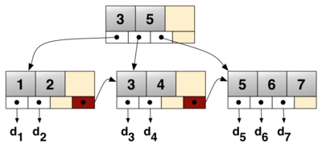
* Inorder traversal can be achieved by just going through the left most leaf node and then going one after another.